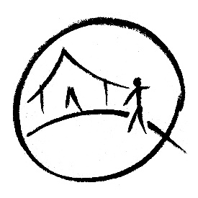
On The Hill – Photo Release Form

Name of school/group:

Date/s of visit:

We are looking forward to welcoming your school/group to On The Hill.

We may film or take photos of visiting schools during their visits which may be used to promote On The Hill, either in our printed publicity or on our website.
No material will be distributed to any third parties.
Please sign below to confirm whether your group is willing to be filmed or photographed during their visit.

Our group is NOT / WILLING [please delete as appropriate] to be filmed or photographed. If you are willing but there are exceptions, please detail their names here:

Signed: [print name]
Dated:
Please return via email to rosie@onthehill.camp
Best wishes,
The On The Hill team

